A FREE GUIDE FOR DOG OWNERS
A Few Minutes a Day
Five simple fixes for everyday dog behavior problems

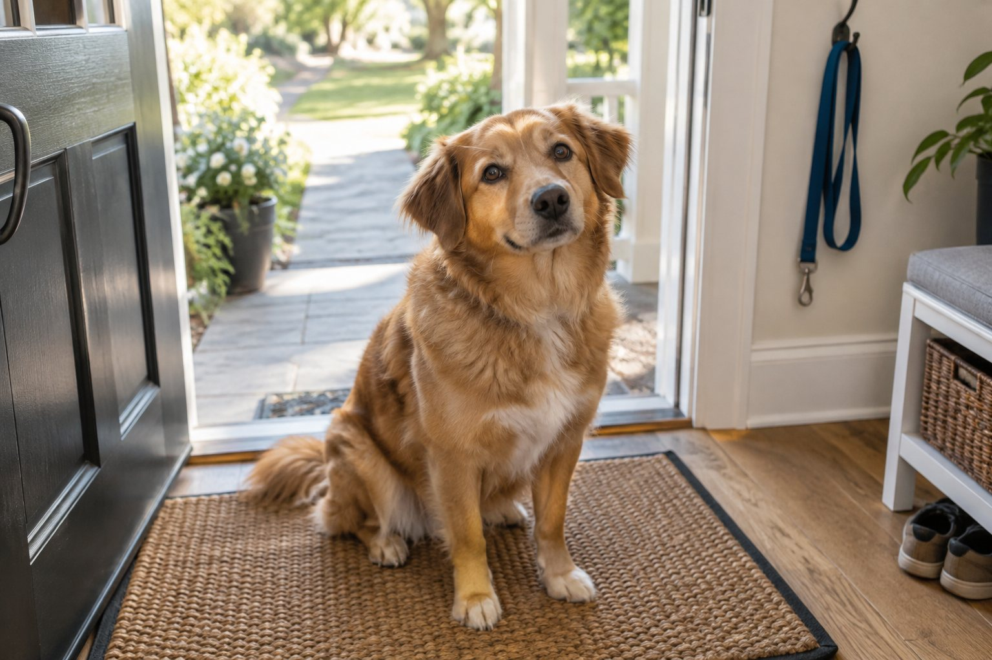
Coming when called | Catching mistakes | Mealtime manners | Leash pulling | Jumping on visitors
Short, practical fixes drawn from the teaching of professional dog trainer Dan Stevens, author of Secrets to Dog Training, with a checklist for each one and a printable seven-day practice sheet.
Shared with you by {{AFFILIATE_NAME}}

Contents
Before you start 2
Fix 1: Make "Come" the best word your dog knows 3
Fix 2: Catch it in the act, or let it go 4
Fix 3: Sit before the bowl 5
Fix 4: Leash basics that end the tug of war 6
Fix 5: Four paws on the floor for visitors 7
Your seven-day practice sheet 8
Quick reference and safety note 9
Where to go from here 10
Recommended by {{AFFILIATE_NAME}} 11
Disclosure and notes 12

Before you start
Your dog is always learning, even when nobody is trying to teach it anything. Professional dog trainer Dan Stevens points out that dogs understand things very differently from people, so ordinary household habits can make behavior problems worse without anyone noticing.
This guide gives you five fixes drawn from Dan's teaching. Each one deals with a problem that a lot of owners live with, and each one takes only a few minutes a day to practice.
How to get the most from this guide
- Start with the one problem that bothers your household most. One habit practiced well will do more than five started at once.
- Practice for a few minutes at a time, once or twice a day, and stop while it's going well.
- Get everyone in the house to use the same words and the same rules, because a dog can't follow rules that change from person to person.
- Use the practice sheet on page 8 to keep track.
- If your dog has bitten anyone, or you think it might, read the safety note on page 9 before you start.

What you'll need
A handful of small treats your dog loves, its usual collar and leash, and a few minutes once or twice a day. You don't need any special equipment.

FIX 1

Make "Come" the best word your dog knows
A dog that comes when it's called is safer and far easier to live with, yet many dogs learn to ignore the recall word. Dan Stevens explains how that happens with the story of a dog called Major. | 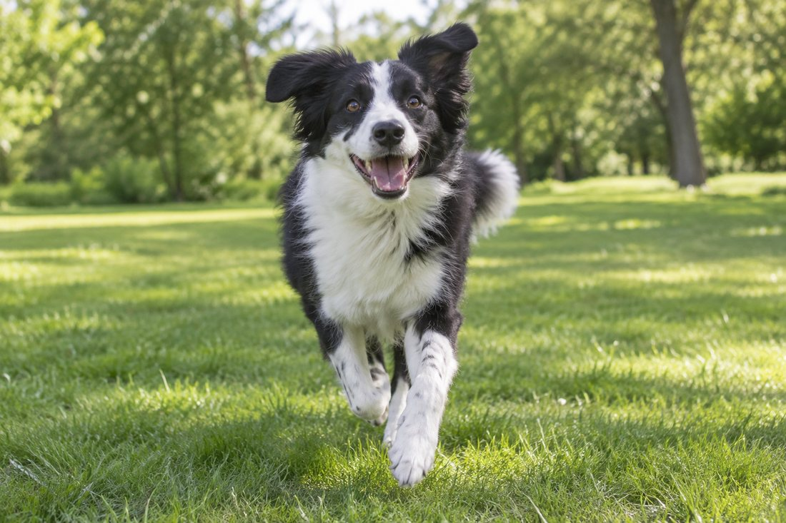

Major and the daisies
Major is out in the garden, digging up a bed of newly planted daisies. His owner calls quietly, "Major, come here," and he carries on digging. The owner shouts it, and he still doesn't come, so the owner marches over, grabs his collar, says "I told you to come here!" and smacks him.
Major is a smart dog, and he makes a mental note that "come here" means he's in trouble. The next evening, when his owner calls him in for dinner, he runs the other way.

Dan's rule is simple. Never use your recall word to scold your dog, correct it or call it for anything it won't enjoy. Your dog needs to learn that "come" always means good things.
Do this today
- Pick one recall word, and make sure everyone in the house uses the same one.
- Practice indoors first, from a few steps away. Say the word once in a happy voice, and praise your dog or give a small treat the moment it reaches you.
- Make coming to you worth it every time, with praise, a treat, a game or its dinner.
- If you need your dog for something it won't like, such as a nail trim, don't call it. Dan's advice is to ask for a Sit and go and get it.
- Don't call when you can't follow through. If your dog is chasing a squirrel across the park, calling only teaches it that the word can be ignored, so walk over and get it instead.
"Now anytime I call my puppy to come, he rans as fast as he can, because he knows that he will get a lot of love for coming to me!!!"
Anna Kovalenko, New York, USA

FIX 2

Catch it in the act, or let it go
Dan is blunt about one old house-training habit: rubbing a puppy's nose in its mess. The puppy doesn't understand why it's happening, so it doesn't learn to go outside. Dan says punishing a dog this way frustrates it and stunts its learning, which makes training harder.  The same goes for any mistake you find after it has happened. Dan's rule is that bad deeds must be caught in the act, because a dog can't connect a telling-off with a shoe it chewed an hour ago. | 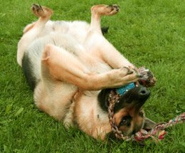  Give your dog things it's allowed to chew.

The fix
- Reward the right thing at the right moment. When your puppy goes to the toilet outside, praise it right there, every time.
- Take your puppy out often, especially after meals, naps and play, and stay with it so you're there to praise it.
- If you catch your dog in the act, interrupt with a calm, firm "No", show it the right place or the right toy, and praise it when it gets it right.
- If you find a mess or some damage later, clean it up and say nothing.
- When you can't watch your dog, limit what it can reach. Put shoes away, close doors, and use a crate or a dog-safe room.
- Give your dog things it's allowed to chew, and praise it for choosing them.
"By using the training techniques outlined in this manual we now get a full nights sleep (no crying & barking in the wee small hours), and every morning we come downstairs to a clean floor with no accidents to mop up."
John & Jackie Robson, Redcar, UK

FIX 3

Sit before the bowl
Mealtime is the easiest training session of the day, because your dog already wants what you're holding. Dan teaches that a dog feels safe and secure when it sees you as a strong, consistent leader, and calm control of the food bowl is one of the simplest ways to show it. | 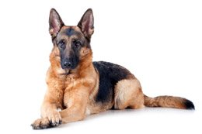

Five steps at every meal
- Prepare the food, pick up the bowl and stand up straight.
- Ask for "Sit" once, in a calm, firm voice, and don't keep repeating it.
- Wait. If your dog jumps, barks or fidgets, lift the bowl back up and wait until it settles.
- When it sits, start lowering the bowl. If it gets up, the bowl goes back up.
- Once the bowl is on the floor and your dog is still sitting, release it with "Okay" and let it eat in peace.
Two more habits that send the same message
- Go through doorways first. Ask your dog to sit and wait, step through, then invite it to follow.
- Eat your own meal first, and don't feed your dog from the table. Keep treats for training.

"He sits and waits so quietly for his dinner we have honestly forgotten he is still waiting once or twice and he has come to remind us 5 minutes later!"
Cara McLean, Cambridge, UK, about her German Shepherd Jack

Safety: if your dog growls or goes stiff when anyone comes near its bowl, don't try to take the food away. Read the safety note on page 9.

FIX 4

Leash basics that end the tug of war
Pulling on the leash often starts before you leave the house. A dog that charges out of the door first and sets the pace has every reason to think it's leading the walk, and when an owner pulls back, many dogs lean forward even harder. | 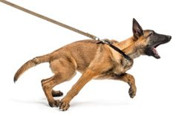  Pulling often starts at the front door.
  "I was completely unaware that I had to go through doorways first; instead, I always let him go first."
  Antonio Gull, about his dog Bello

Your leash routine
- Calm first. Ask for a Sit and clip the leash on only when your dog is sitting. If it jumps up, hang the leash back up and wait a minute.
- You go first. Your dog waits at the door and follows when you invite it.
- Never yank the leash. A sharp jerk makes many dogs pull harder.
- Tight means stop. When the leash goes tight, stand still and say nothing. When it goes slack, praise your dog and walk on.
- Reward your side. When your dog walks beside you on a loose leash, tell it so, and give a small treat now and then.
- Walk tall. Keep your voice calm. Dan points out that your posture, eye contact and body language really matter to dogs.
- Only commands you can back up. Don't keep saying "heel" while your dog drags you along.
- Little and often. Start in quiet places and practice for a few minutes every day.
"I try to talk a softer tone and don't yank on the leash as hard anymore and get better results."
Ben Richmond, Florida, USA

Dan's complete leash method, including Heel taught in three stages, is in Secrets to Dog Training. See page 10.
FIX 5

Four paws on the floor for visitors
A dog that jumps on visitors is usually just pleased to see them, but it can knock over a child, frighten a guest or ruin clothes. The fix is a rule that never changes, and visitors who know what to do. | 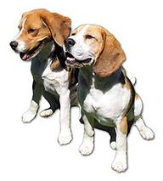
  "Our Bichon, Jasmine, is a very friendly little dog who loves everyone she meets and shows it by jumping up on them. By following the instructions in your Secrets to Dog Training book, we were able to control her jumping."
  Dr. Stanley Hyman, Winnipeg, Manitoba, Canada

Before the doorbell rings
- Agree on one rule: no jumping on anyone, ever. That includes family members during play, because a dog that's allowed to jump on you will jump on guests too.
- Tell visitors what to do before you open the door: no eye contact, no talking and no touching until your dog has four paws on the floor.
- Give your dog some exercise before guests arrive, so it has less energy to burn.
- Watch for the signs that a jump is coming, such as heavier panting, a wagging tail and a few excited circles, and step in calmly at that moment.

When your dog jumps
- Turn away, fold your arms and stay quiet. Don't push your dog off with your hands or knees, because pushing invites it to push back.
- The moment all four paws are on the floor, ask for a Sit.
- When it sits, greet it calmly. If it jumps again, turn away again.
- Practice with friends or family arriving at the door a few times in a row, so your dog gets plenty of chances to get it right.

Dan's book teaches six simple techniques for dogs that jump up. See page 10.
PRINT THIS PAGE

Your seven-day practice sheet
Keep this page somewhere you'll see it, such as the fridge door, and tick a box each day you practice. Start with one or two fixes, and add more when they're going well.
Fix | Day 1 | Day 2 | Day 3 | Day 4 | Day 5 | Day 6 | Day 7
Fix 1: Come means good things | ☐ | ☐ | ☐ | ☐ | ☐ | ☐ | ☐
Fix 2: Catch it in the act | ☐ | ☐ | ☐ | ☐ | ☐ | ☐ | ☐
Fix 3: Sit before the bowl | ☐ | ☐ | ☐ | ☐ | ☐ | ☐ | ☐
Fix 4: Calm leash routine | ☐ | ☐ | ☐ | ☐ | ☐ | ☐ | ☐
Fix 5: Four paws for visitors | ☐ | ☐ | ☐ | ☐ | ☐ | ☐ | ☐

Our house rules
Our recall word | _______________________________
Our release word | Okay
Jumping | Never, on anyone
Doors | People go first
Meals | Sit before the bowl goes down
Leash | Tight means stop, slack means go

What's getting better:
What's still hard:
KEEP IT HANDY

Quick reference
Cut this card out and keep it by the front door or on the fridge, so everyone in the house follows the same five rules.
1 Come means good things. Never call your dog to scold it.
2 Catch it in the act, or let it go. Reward the right place, every time.
3 Sit before the bowl. The food goes down when your dog sits calmly.
4 Tight leash, stand still. Slack leash, walk on.
5 Four paws on the floor. Nobody says hello until then.

A safety note
These fixes are for everyday manners. If your dog has bitten anyone, guards its food or toys, or lunges at people or other dogs, get help in person from a qualified professional as well as using any book or guide, and keep children and visitors at a safe distance until then.
If your dog's behavior changes suddenly for no clear reason, have it checked by your vet.

Around children
- Teach children not to play tug-of-war or wrestling games with the dog.
- Never let children grab a dog's tail or paws.
- Children should always ask the owner before stroking someone else's dog, and never approach a dog that's tied up on its own.

THE NEXT STEP

Where to go from here
All five fixes come back to one idea that runs through Dan Stevens' teaching: a dog does what it understands, so your job is to make the message clear and keep it the same every day.
Dan's sister Jen found out what happens when that message never gets through. She gave her German Shepherd, Aladdin, the best of everything, but he jumped on visitors, got on the furniture and barked so much that the neighbors threatened to call the pound. Then one night, on a walk, he bit a young college student. Lawyers got involved, and Jen had to sell her car to pay for a year of the student's tuition and board.  When Jen read Dan's book, she realized she had been training Aladdin the wrong way all along. Today he sits, rolls over, fetches the newspaper and enjoys other dogs. | 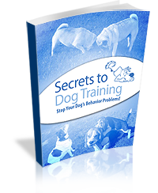
  "It made a world of difference for my sister and her dog. Anyone would agree if they saw him that Aladdin is now a pleasure to be around."
  Dan Stevens

Dan is a professional dog trainer, and owners rely on his advice. He wrote down the tips he's picked up from his years of experience, step by step, so ordinary owners can do what professionals do, and over 220,000 dog owners have used his book.
What the full guide adds
- Step-by-step help with photos for over 25 behavior problems, including barking, chewing, digging, bolting out of the door, separation anxiety, aggression and house training
- Six simple techniques for dogs that jump up
- Dan's leash technique, which he says stops leash pulling in ten minutes or less, with Heel taught in three stages
- A 30-minute video, so you can see the methods on screen
- Unlimited consultations with Dan and the Secrets to Dog Training team in the members' forum

If one of the fixes made a difference this week, turn the page to see why {{AFFILIATE_NAME}} recommends the full guide.
RECOMMENDED BY {{AFFILIATE_NAME}}

Secrets to Dog Training: Stop Your Dog's Behavior Problems!
A note from {{AFFILIATE_NAME}}: [Add one honest sentence about your own dog or your readers]

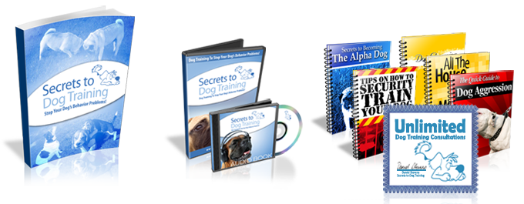
 | 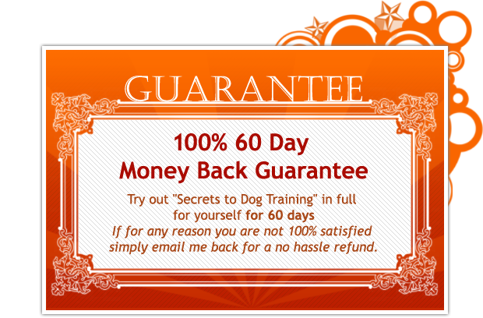
  What you get
  - The 256-page, full-color eBook by professional dog trainer Dan Stevens
  - The 30-minute video program and the audio book
  - The Secrets to Becoming the Alpha Dog eBook
  - Four bonus eBooks on aggression, house training, grooming and security training
  - Unlimited consultations with Dan and the Secrets to Dog Training team in the members' forum

$39.95, one payment, instant download | 60-day money-back guarantee, no questions asked | 66 customer reviews: 43 five-star and 23 four-star

See Secrets to Dog Training
Or type this link into your browser: {{AFFILIATE_LINK}}
{{AFFILIATE_NAME}} may earn a commission if you buy through this link, at no extra cost to you.

Disclosure and notes

Affiliate disclosure
{{AFFILIATE_NAME}} shares this guide free of charge and is an affiliate of Kingdom of Pets, the company that sells Secrets to Dog Training. If you buy through the links in this guide, {{AFFILIATE_NAME}} may earn a commission, at no extra cost to you.

About this guide
The fixes in this guide are drawn from the published teaching of Dan Stevens, author of Secrets to Dog Training: Stop Your Dog's Behavior Problems!, sold by Kingdom of Pets. Customer quotes are reproduced word for word, with the customers' own spelling, from reviews on the Kingdom of Pets order page.
Product details and prices were correct when this guide was written. The official order page always has the latest. Orders are processed by ClickBank.

Your dog's safety
This guide gives general training information for everyday manners. It doesn't replace in-person help from a qualified professional or advice from your vet. Please read the safety note on page 9, and remember that every dog is different, so progress depends on the dog and on regular, consistent practice.

 | Secrets to Dog Training is sold by Kingdom of Pets.

